- 搭建后台项目架构
- 项目架构
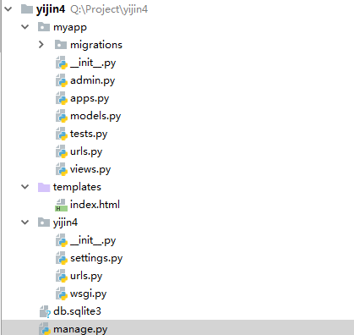

2、解决跨域问题

1、安装django-cors-header
这时候我们须要在Django层注入header，用Django的第三方包django-cors-headers来解决跨域问题。
pip install django-cors-headers
- 加载CorsMiddleware中间件
在settings.py文件中：
MIDDLEWARE = [
'django.middleware.security.SecurityMiddleware',
'django.contrib.sessions.middleware.SessionMiddleware',
'corsheaders.middleware.CorsMiddleware',
'django.middleware.common.CommonMiddleware',
'django.middleware.csrf.CsrfViewMiddleware',
'django.contrib.auth.middleware.AuthenticationMiddleware',
'django.contrib.messages.middleware.MessageMiddleware',
'django.middleware.clickjacking.XFrameOptionsMiddleware',
]
注意中间件的先后顺序，同时配置允许跨域。
CORS_ORIGIN_ALLOW_ALL = True
- 具体实现
- myapp.views
from django.shortcuts import render
from django.http import JsonResponse
from django.views.decorators.http import require_http_methods
import json
from django.core import serializers
@require_http_methods(["GET"])
def say_hello(request):
response = {}
try:
users = {"name":"czf","age":40,"address":"北京昌平"}
#response['users'] = json.loads(serializers.serialize("json", users))
response['users']=users
response['msg'] = 'success'
response['error_num'] = 0
except Exception as e:
response['msg'] = str(e)
response['error_num'] = 1
return JsonResponse(response)
# Create your views here.

- myapp.urls
from django.conf.urls import url
import myapp.views as vw
urlpatterns = [
url(r'^hello$',vw.say_hello)
]

- urls.py
from django.contrib import admin
from django.urls import path
from django.views.generic import TemplateView
import myapp.urls
from django.conf.urls import include,url
urlpatterns = [
path('admin/', admin.site.urls),
url(r'^api/', include(myapp.urls)),
url(r'^$', TemplateView.as_view(template_name="index.html")),
]

其中 url(r'^api/', include(myapp.urls))是把myapp下的url引入到系统的url中来。
访问前要加api

